Name:  Class: | ____________________________________  ________________ |  | Date:_________
 | Year 11 Essential Mathematics  / 42  Unit 1 Test 3 2019  Topic – Graphs
Total Time: | 45 minutes
Weighting: | 4%
Equipment: | To be provided by the student: Pen, pencil, ruler,1 A4 page of notes, scientific calculator

Full working out must be shown to get full marks. Attempt all questions.

- [5 marks: 1,1,1,2]
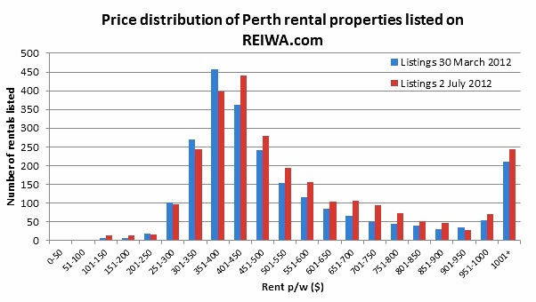
  - From the above graph what is the lowest rent per week?

  - What is the highest rent per week?

  - Which rent bracket has the most number of rentals?

  - Explain why the $1001 + rent p/w column has a sharp increase compared to the previous columns.

- [10 marks: 7,1,1,1]

56 children were asked which of the following hobbies they prefer. Their results are recorded in the table below.

 | Computer games | Watch Films | Read | Total
Girls | 5 |  |  | 22
Boys |  | 11
Total | 24 |  | 10

- Complete the missing values

- How many boys prefer computer games?

- What percentage of children watched films?

- What percentage of girls read books?

- [4 marks]
Police recorded the average number of people caught drink driving on the same section of road on different nights of week.
Monday | 5 | Tuesday | 6 | Wednesday | 4 | Thursday | 10
Friday | 12 | Saturday | 17 | Sunday | 8

Represent the above information as a pictograph. Use a bottle to represent two people.

- [3 marks]

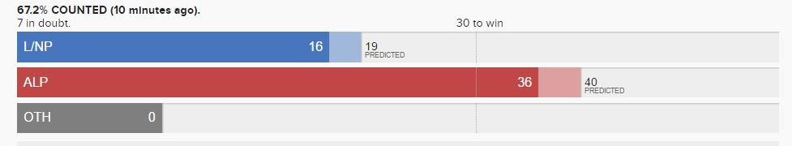

List 3 things that are missing or wrong with this graph.

- [6 marks]
The following data set shows the temperatures over 1 day.

Time | Noon | 3pm | 6pm | 9pm | Midnight | 3am | 6am | 9am | noon
Temperature | 30C | 33C | 30C | 29C | 25C | 23C | 22C | 28C | 32C

Draw an appropriate graph for this data

- [6 marks]

Suggest which data display or graph would be best for each data set and give your reason

Data | Display/graph | Reason
The percentage of students in each year group at school

The price of fuel over a week

The favourite chocolate bars of students at school

- [8 marks: 1,1,2,2,2]
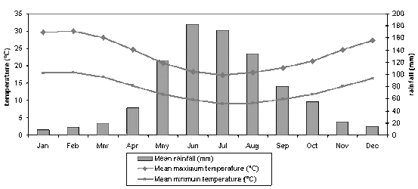
  - What is the mean maximum temperature in September?

  - Which month has the coldest mean minimum temperature?

  - What is the difference between the mean maximum and mean minimum temperatures in May?

  - How much more rain falls in June than December?

  - Describe the annual rainfall pattern?

